DB-C4-S3-THEORY VIEW

This exercise is based on given ONLINE database:

<https://www.w3schools.com/sql/trysql.asp?filename=trysql_select_where>

* Test your queries on the online editor
* Copy / paste your answer for each question on this document

**Q1:** Write a query to create a view for all customers who are coming from France.

CREATE VIEW CUSTOMER_FRANCE AS Select * from Customers where Country=”France”;

**Q2:** Write a query to create a view of order quantity more than 50.

CREATE VIEW ORDERThan50 AS select * from OrderDetails where Quantity > 50;

**Q3**: Write a query to create a view of products with a price between $10 and $30.

CREATE VIEW Products AS SELECT * FROM Products where Price between 10 and 30 order by Price

**Q4**: Write a query to create a view of suppliers coming from Japan and only from Tokyo city.

CREATE VIEW SUP_JAPAN AS SELECT * FROM Suppliers Where City=”Tokyo” and Country=”Japan”;

**Q5:** Write a query to create a view to display product name in each category without any duplicate.

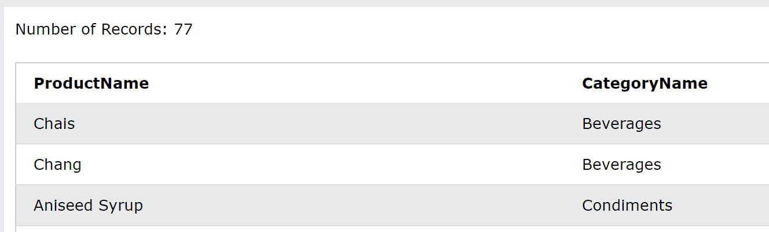

CREATE VIEW PRODUCTLIST AS select ProductName, CategoryName From Products INNER JOIN Categories ON Products.CategoryID=Categories.CategoryID

**Q6:** Write a query to create a view to display all customers and employees as seller

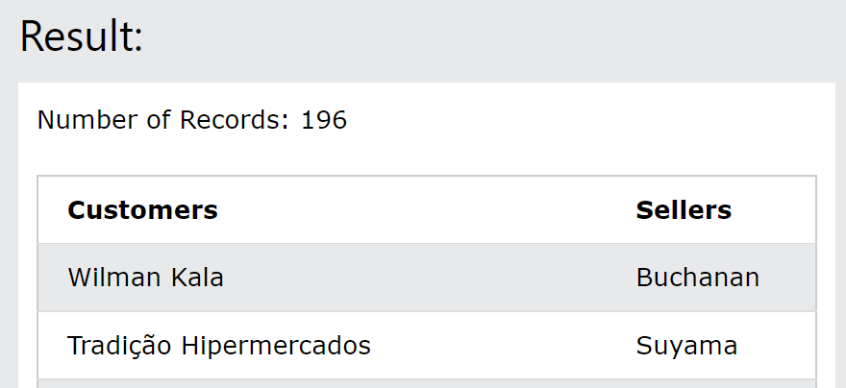

CREATE VIEW NAME AS SELECT Customers.CustomerName, Employees.LastName AS [Sellers] FROM (( Orders

INNER JOIN Customers ON Orders.CustomerID=Customers.CustomerID)

INNER JOIN Employees ON Orders.EmployeeID = Employees.EmployeeID);

Q7: Write a query to create a view for those salesmen belongs to the city New York.

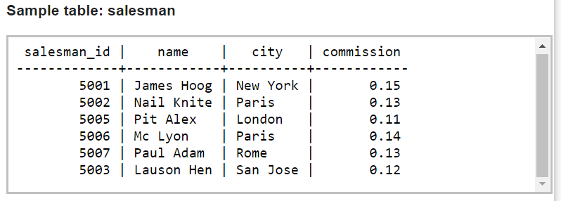

CREATE VIEW saleman select * from salement;

**Q8:** Write a query to find the salesmen of the city New York who achieved the commission more than 13% with the view you just created in Q7.

Select * from salement where commission > 13;